UIS Green Projects Application
Full Project Proposal- Step 2

To complete your Full Project Proposal, download this word document and type all answers to the questions below. Save your completed word document along with any supporting documentation (excel spreadsheet of budgeted itemized items, letters of support, and so on) as new files. Supporting files in Word (.docx) format should be attached to the end of this application in order to create only one Word document. Supporting files in all other formats (pdf, excel, PP) may be submitted as separate documents.

Once completed and saved to your device, return to the Green Projects website at http://www.uis.edu/greenprojects/get-involved/

Click the hyperlink titled, “Submit your completed UIS Green Project Proposal”
This can be found under Step 2 of the “Submit a Green Project Proposal” section.

You will be redirected to an external WebQ. Upload your completed application along with any supporting documentation by the deadline found in the “Timeline” section of the Green Projects website.

NOTE: Please do not submit this application unless you have been formally invited to do so by the UIS Green Fee Committee.

If you have any questions regarding the application or submission process, please contact us at greenprojects@uis.edu.

Project Name: Campus Raingardens

Contact Information:

Project Team
Name | UIS Student/Faculty/Staff & Department (or Office) | UIS Email | Phone #
Nancy Cano | UIS Student | ncano4@uis.edu | 630 597 3266
Brian Beckerman | Grounds Superintendent | bbeck1@uis.edu | 217 206 7202

Organization/Affiliation: None

Project Information:
Provide a brief description of the project, its goals, and the desired outcomes:
This project will allow the planting of one or two raingardens at Old Campus.

Rain gardens consist of native plants that are accustomed to lots of water, meaning that they can limit flooding. The goals and outcomes of this project is to have more native plants on campus, to make campus be flood resilient, to attract more pollinators to campus, and to make campus look more beautiful in a sustainable way.

How will this project improve sustainability at UIS?
Implementing raingardens is a simple way to make campus more sustainable by making campus more flood resilient and promoting native plants.

Please indicate how this project will involve or impact students. What role will students play in the project?
There are many ways that students can be involved in this project. I talked to Brian Beckerman, the UIS Grounds Superintendent, who mentioned that students could take part in doing the labor for the implementation of these raingardens.

I also envision that the UIS Community Garden as the project pertains to plants, gardening, and sustainability. The grounds staff at UIS will also need to be involved as the location of the project will fall under their domain.

After these rain gardens are installed, students will also enjoy beautiful raingardens and its flood-resilient effects!

Where will the project be located? Do you need special permissions to enact the project at this site? If so, please explain and attach a letter of support to your application. If you are not sure, let us know! We can help.
This project will allow the planting of one or two raingardens at Old Campus, to the west of the Student Life Building and the Visual and Performing Arts Building. These areas are prone to heavy flooding, and the water to the west of the SLB often affects other parts of campus as well.

I have talked to Brian Beckerman about this idea, and he is alright with the Grounds team to work on it.

I have provided a map below of the general locations. The red shapes are where the raingardens would likely be.
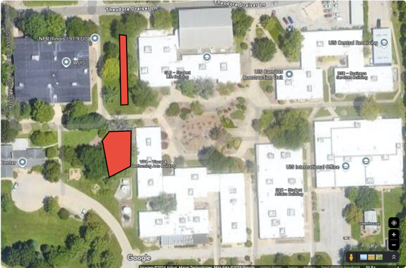

I also provided pictures of the flooding in these areas:

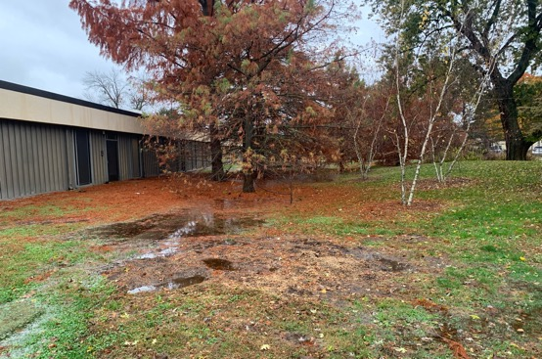
Figure 1: West of VPA
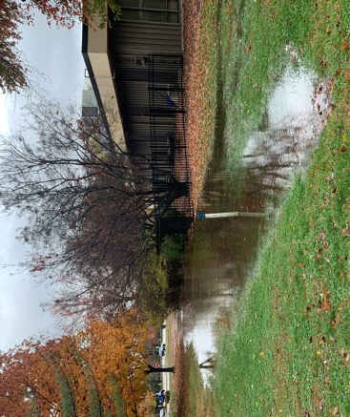
Figure 2: West of Student Life Building
Other than the project team, who will hold stake in the project? Please list other individuals, groups, or departments indirectly or directly affected by this project. This includes any funding entities (immediate, future, ongoing, etc.) and any entities that will be benefiting from this project. Communication with affected departments is encouraged ahead of time. List the names of who you spoke with and their comments.
- Grounds team
  - Brian Beckerman. He recommended the two locations above and the estimate area measurement and costs of the materials for these locations.
- Dr. Thomas Rothfus. I was unable to meet with him prior to the proposal deadline. However, I have a meeting with him soon about this project!
- Maybe the Volunteer and Civic Engagement Center if they want to promote a volunteer event for students to take part in implementing these gardens.

Have you applied for funding from the Student Green Fee previously? If so, for what project?
I submitted an LOI for a film on an activist of color this semester.

Scope, Schedule, and Budget verification

Do you have a plan for project implementation? Describe the key steps of the project.
- Buying the materials for the project.
- Mapping out the exact location/s that these raingardens will be.
- Implementing raingardens
- Measuring effectiveness of project
  - Measure the area and height of the water in floods in these locations before the raingardens are implemented. After raingardens are planted and the plants have grown, measure these floods again and see if the area and height of the water has decreased, increased, or stayed the same.

List all budget items for which funding will be required. Include the cost for each item requested. Please be as detailed as possible, to the best of your ability. If you know where you would like to purchase materials from, please list the contact information of the retailer(s) below, along with the URL addresses to each item you will be requiring. If you need suggestions for how and where to purchase materials, please contact the Student Sustainability Projects Coordinators by email.

 | Location 1 (West of SLB) | Location 2 (West of VPA) | Other comments
Area Estimate | 4,000 square feet | 1,000 square feet | Information provided by Brian Beckerman
General | $4,800 for plant material and some river gravel  About 1,760 plants (based on 18" center between plants from Forrest Keeling guide, Figure 3) | $1,200 for plant material and some river gravel  About 440 (based on 18" center between plants from Forrest Keeling guide, Figure 3) | Information provided by Brian Beckerman
Labor | No cost | No cost | Information provided by Brian Beckerman
Estimated Total | $4,800 | $1,200 | Information provided by Brian Beckerman
Estimated Total for both locations | $6,000 (2,200 total plants)

Possible plants:
Forbs and Grasses
Switchgrass
Cardinal Flower
Swamp Milkweed (good food source for Monarch Butterfly larvae)
Blue Flag Iris
Joe Pye Weed
Purple Coneflower
Rose Mallow
Smooth Phlox
Orange Coneflower
Common Rush
Nodding Wild Onion
Wild Bergamot
Turtlehead
Blazing Star
New England Aster
Foxglove Beardtongue

Shrubs
Redtwig Dogwood
Red Chokeberry
Shorter Viburnum species

Plant Information:
The Red Oak Raingarden - https://redoakraingarden.org/

Sources to buy plants:

Pizzo Native Plant Nursery
- https://www.pizzonursery.com/
- Has native plant plug material

Forrest Keeling Nursery
- https://fknursery.com/
- Great source for native trees and shrubs

Prairie Moon Nursery
- https://www.prairiemoon.com/rain-garden-seed-packet-collection Rain Garden Packet - $ 21
Includes: (2,450 seeds total)
  - Rose Milkweed (Asclepias incarnata) - 100 seeds
  - Joe Pye Weed (Eutrochium maculatum) - 400 seeds
  - Sneezeweed (Helenium autumnale) - 500 seeds
  - Cardinal Flower (Lobelia cardinalis) - 750 seeds
  - Obedient Plant (Physostegia virginiana) - 200 seeds
  - New England Aster (Symphyotrichum novae-angliae) - 500 seeds

3 B Natives
- might not have seed packets, and instead only have plants that cost a lot more.
Examples:
- Rose milkweed, Asclepias incarnata 100 seeds (https://3bnatives.com/products/asclepias-incarnata-swamp-milkweed-seed-packet) - $3
- Sneeze weed, Helenium autumnale 500 seeds (https://3bnatives.com/products/helenium-autumnale-sneezeweed-seed-packet) - $3

Will this project require ongoing funding? Do you have a plan for supporting the project in order to cover replacement, operation, or renewal costs?
According to Mr. Beckerman, there shouldn’t be any ongoing costs.

Every project must be publicized! Where would you like to see information about this project reported?
I hope there will be signage about what raingardens are, their benefits, and who was involved (GFC and grounds team) in making these raingardens.

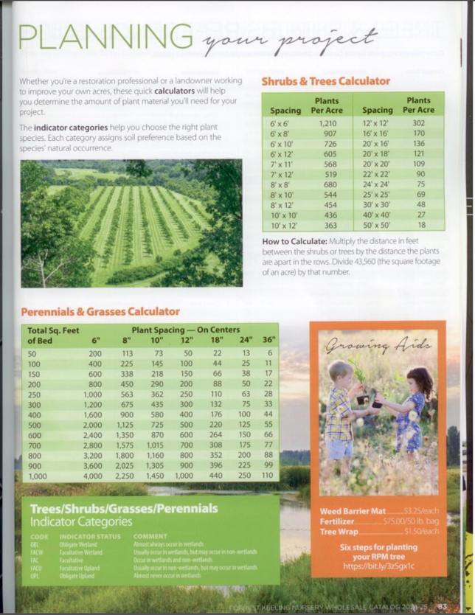
Figure 3: Forrest Keeling guide. Provided by Brian Beckerson

